**Maintaining Sets of Containers with Deployments**

* **Updating Existing Objects:**

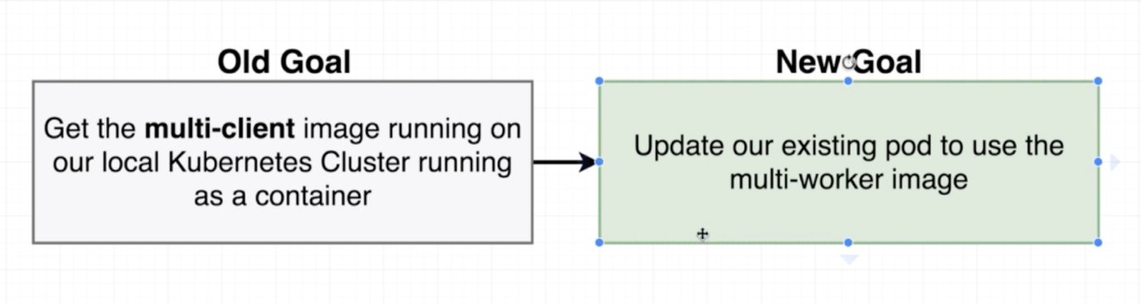

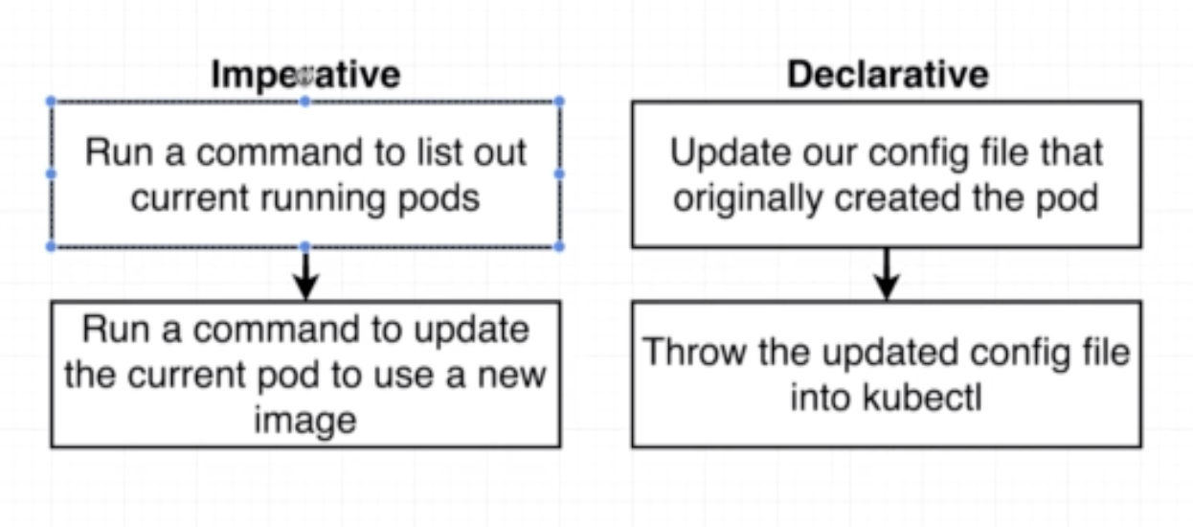

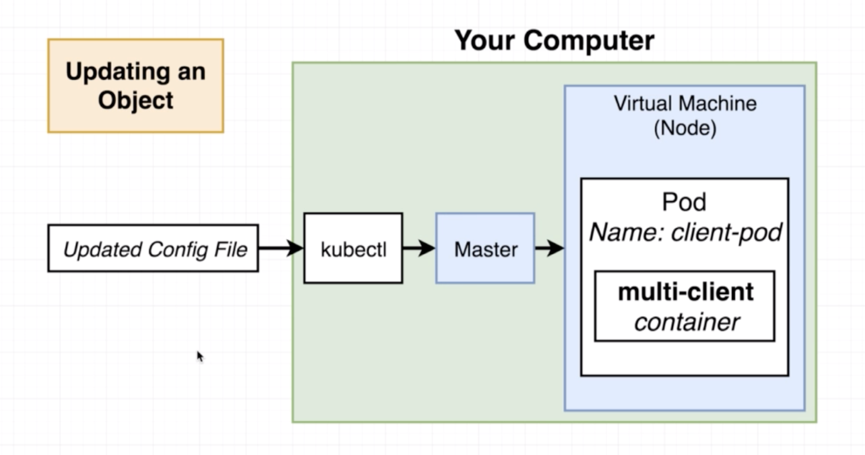

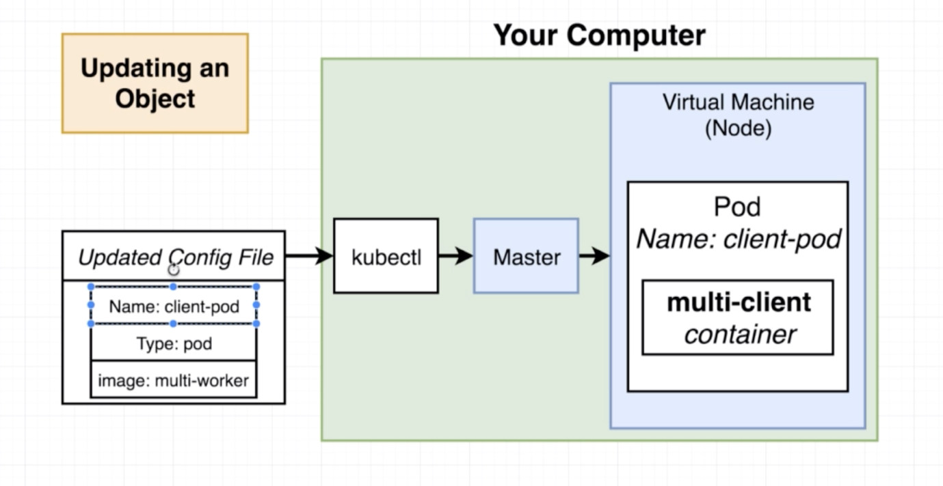

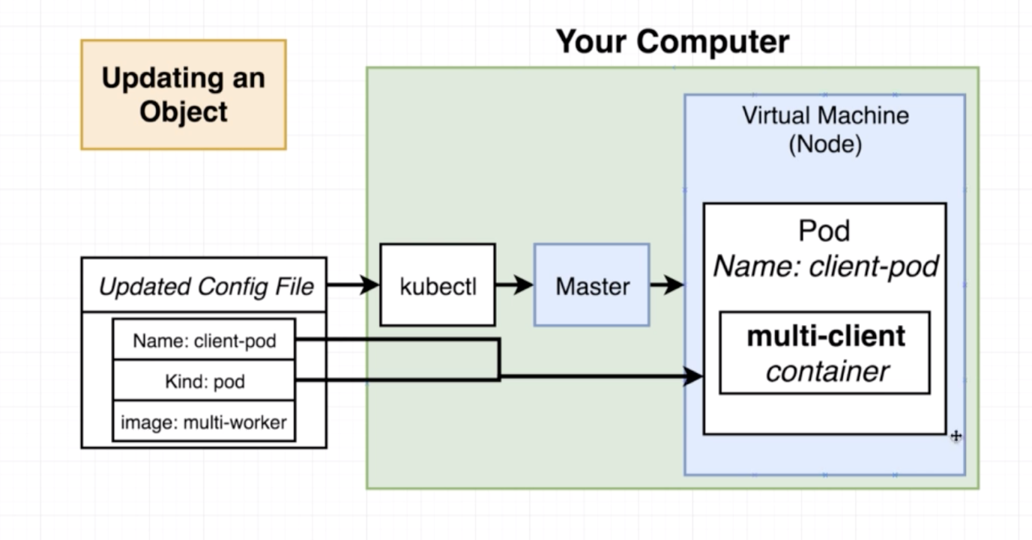

* **Declarative Updates in Action:**

**Note:** As part of this update, the target is to just update the existing pod, not to get the updated pod running, as this worker pod has a dependency of Redis. So this container will crash at start up time.

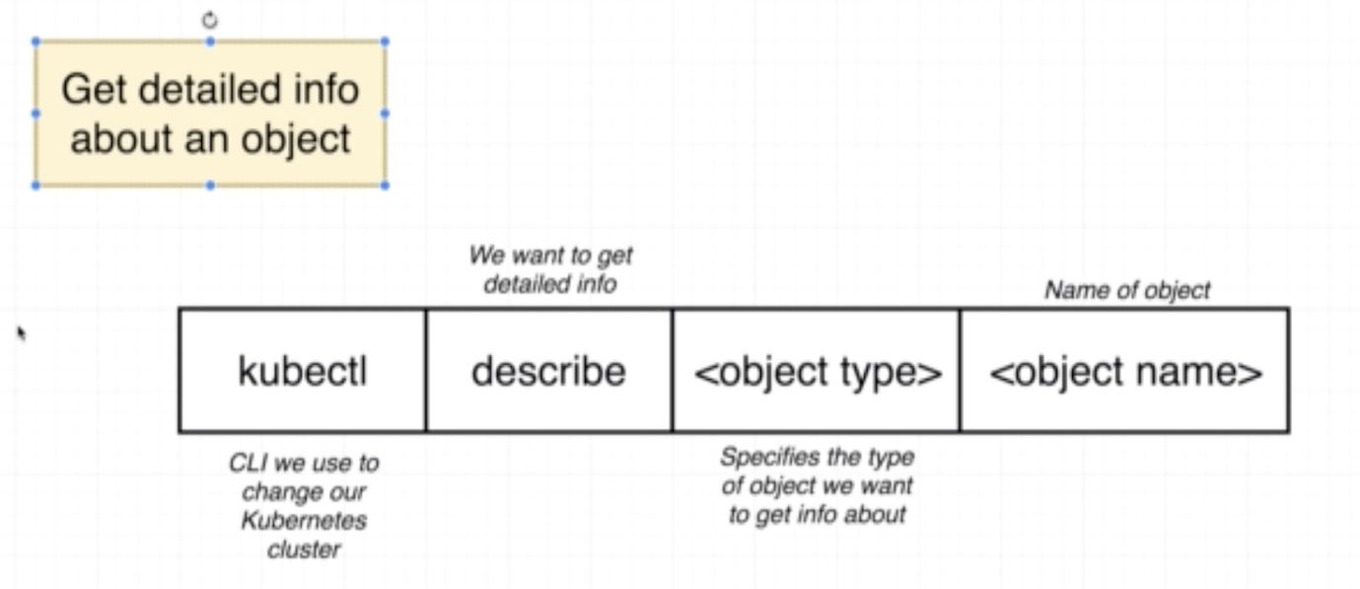

kubectl describe pod client-pod

* **Limitations in Config Updates:**

Let’s try to change the port value of the client-pod to 99999 and run the “kubectl apply -f client-pod.yaml”.

It will throw an error message as shown below.

With pod update, we can only change the fields under “spec.containers[*].image” and the properties listed below. If you try to do any other change, the update will not work. It will throw an error message.

The Pod "client-pod" is invalid:

* spec.containers[0].ports[0].containerPort: Invalid value: 99999: must be between 1 and 65535, inclusive

* spec: Forbidden: pod updates may not change fields other than `spec.containers[*].image`, `spec.initContainers[*].image`, `spec.activeDeadlineSeconds` or `spec.tolerations` (only additions to existing tolerations)

  core.PodSpec{

   Volumes: []core.Volume{{Name: "default-token-lv99b", VolumeSource: core.VolumeSource{Secret: &core.SecretVolumeSource{SecretName: "default-token-lv99b", DefaultMode: &420}}}},

   InitContainers: nil,

   Containers: []core.Container{

   {

   ... // 3 identical fields

   Args: nil,

   WorkingDir: "",

   Ports: []core.ContainerPort{

   {

   Name: "",

   HostPort: 0,

-  ContainerPort: 99999,

+  ContainerPort: 3000,

   Protocol: "TCP",

   HostIP: "",

   },

   },

   EnvFrom: nil,

   Env: nil,

   ... // 14 identical fields

   },

   },

   EphemeralContainers: nil,

   RestartPolicy: "Always",

   ... // 25 identical fields

  }

Note: We can change the above properties with another kind.

* **Running Containers With Deployments**

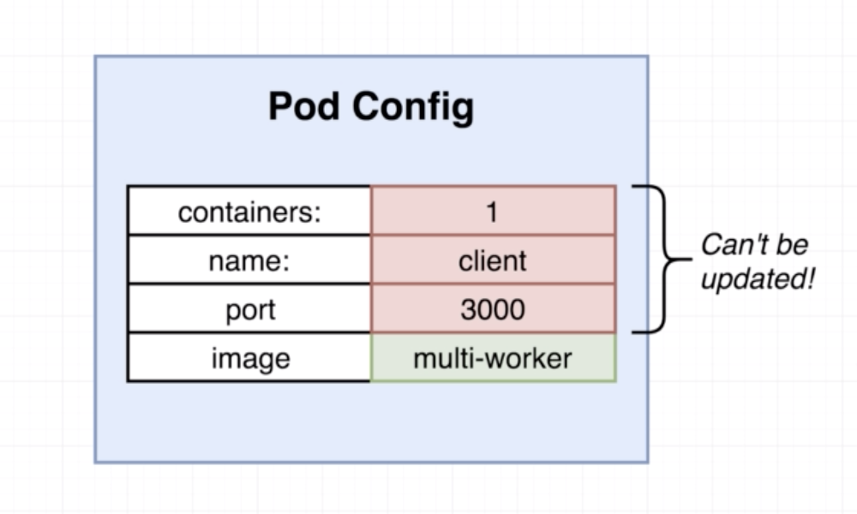

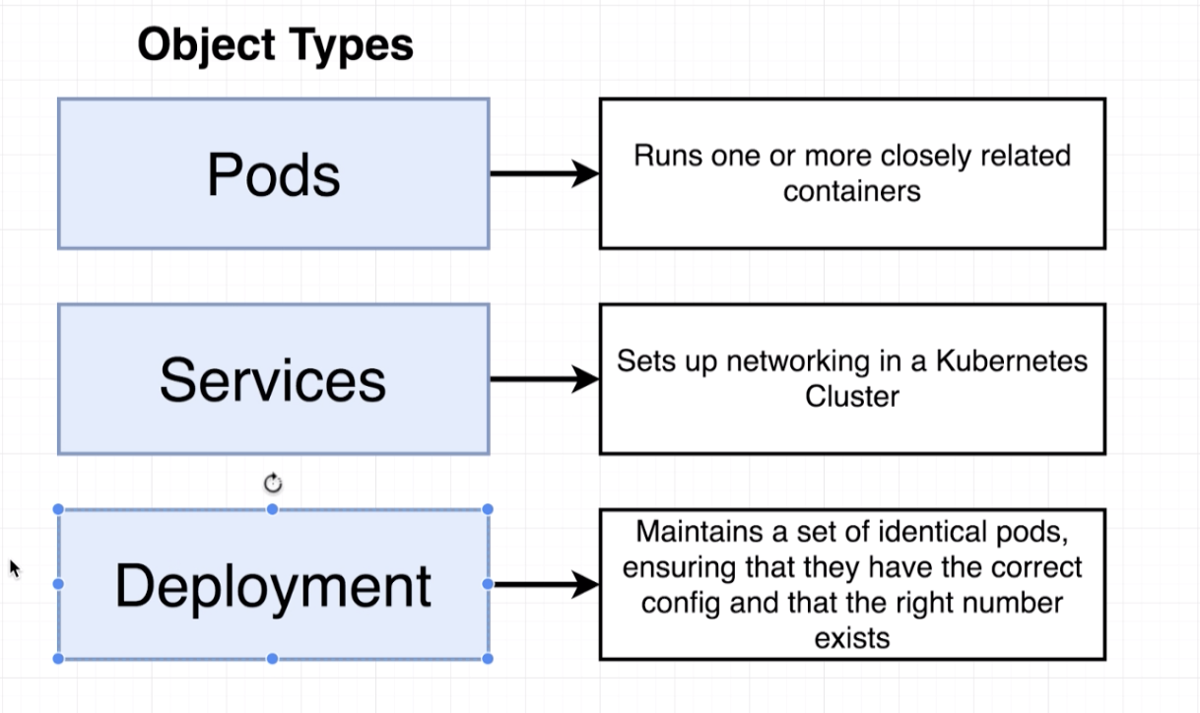

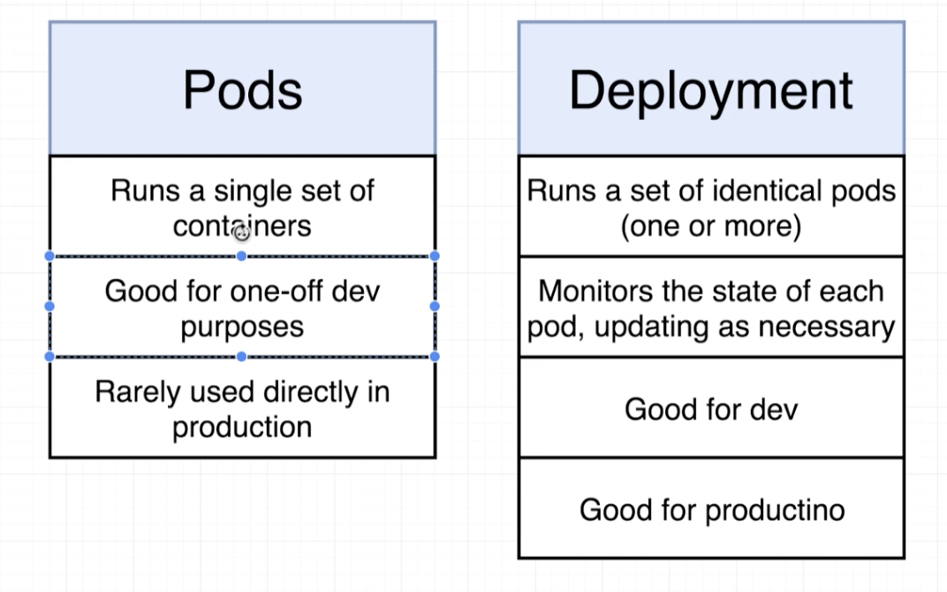

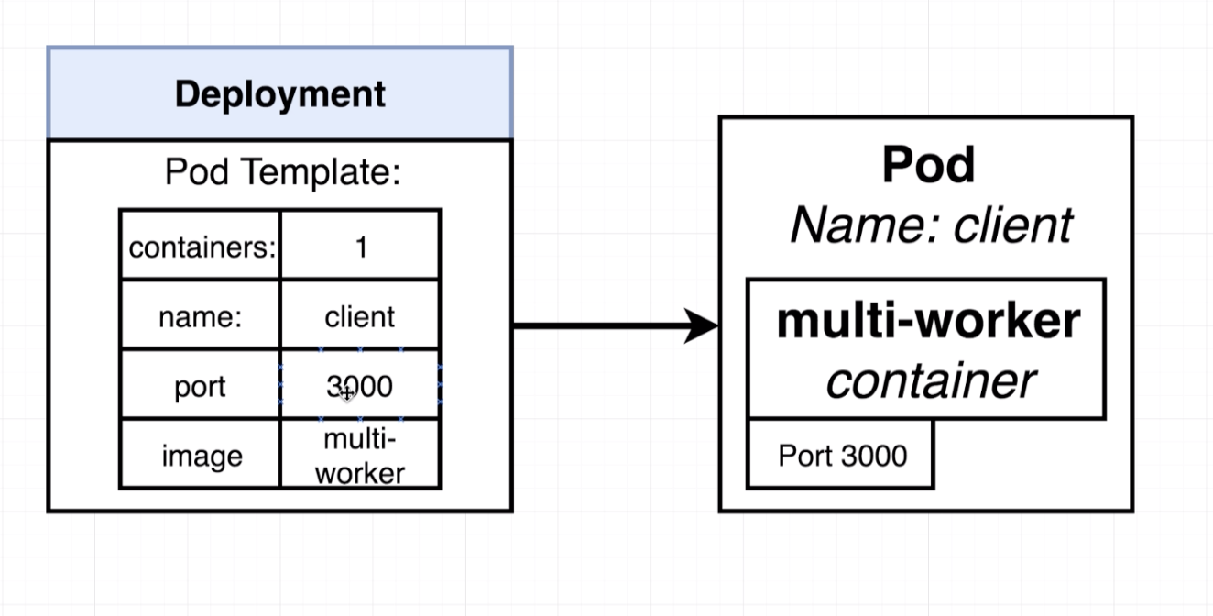

* **Deployment Configuration Files:**

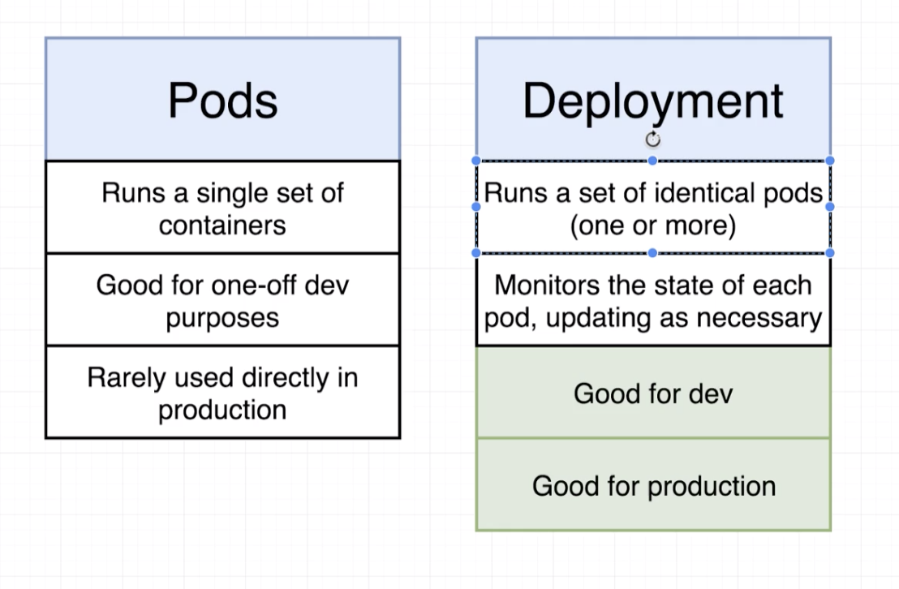

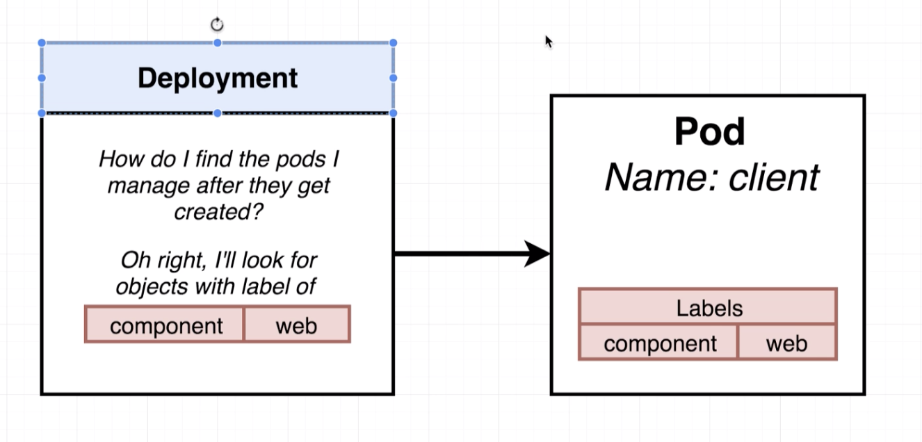

apiVersion: apps/v1

kind: Deployment

metadata:

name: client-deployment

spec:

replicas: 1

selector:

matchLabels:

component: web

template:

metadata:

labels:

component: web

spec:

containers:

- name: client

image: stephengrider/multi-client

ports:

- containerPort: 3000

* **Applying a Deployment:**

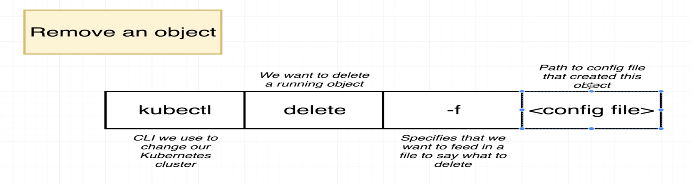

kubectl apply -f client-deployment.yaml

kubectl get deployments

* **Why Use Services?**

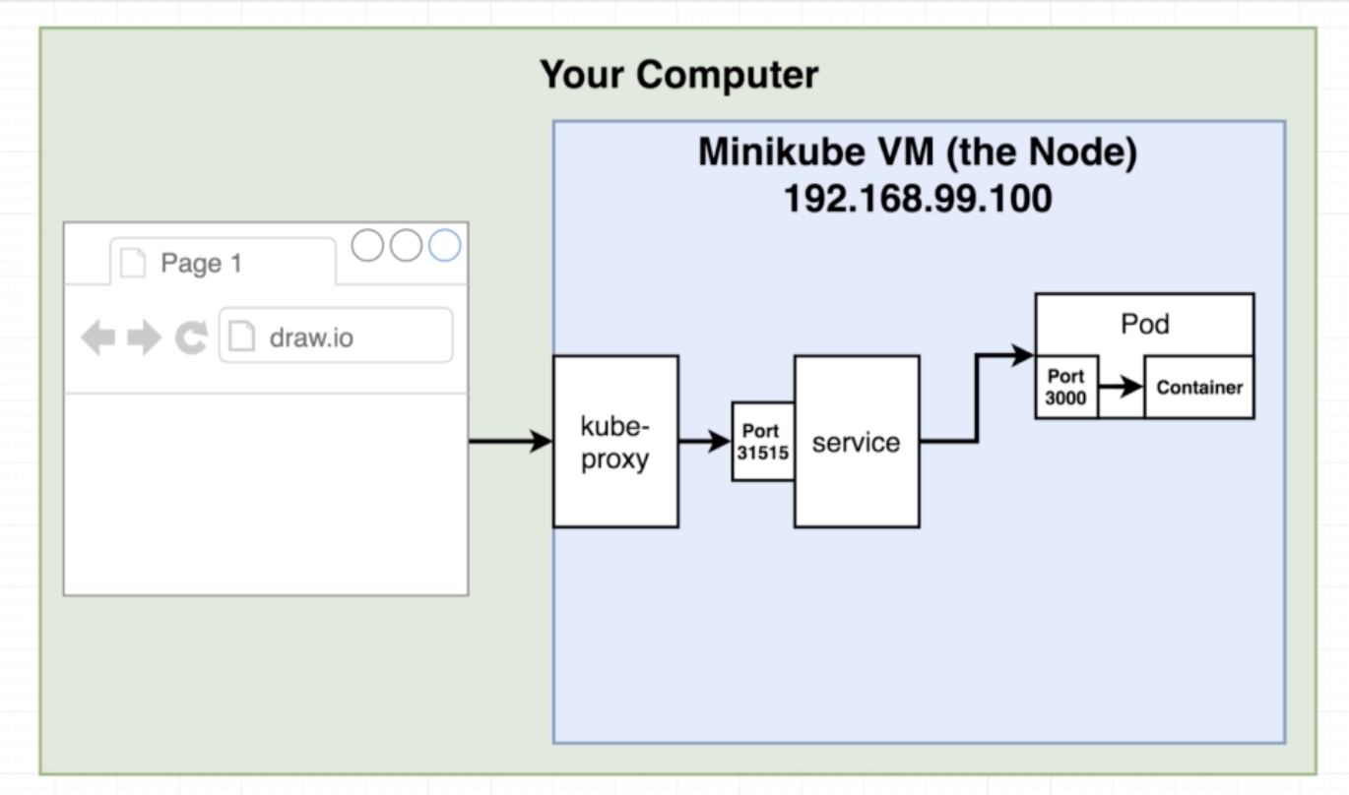

kubectl get pods -o wide



Note: Pods are short lived resource, which may crash or deleted. Whenever we do this, it will change the ipaddress, so if we use the ipaddress of the pod to access, it will throw an error saying unable to find. So we create a service and call the service, service will have the updated information about the pods ip.

Note: Service uses the selector to find the pod associated for the request.

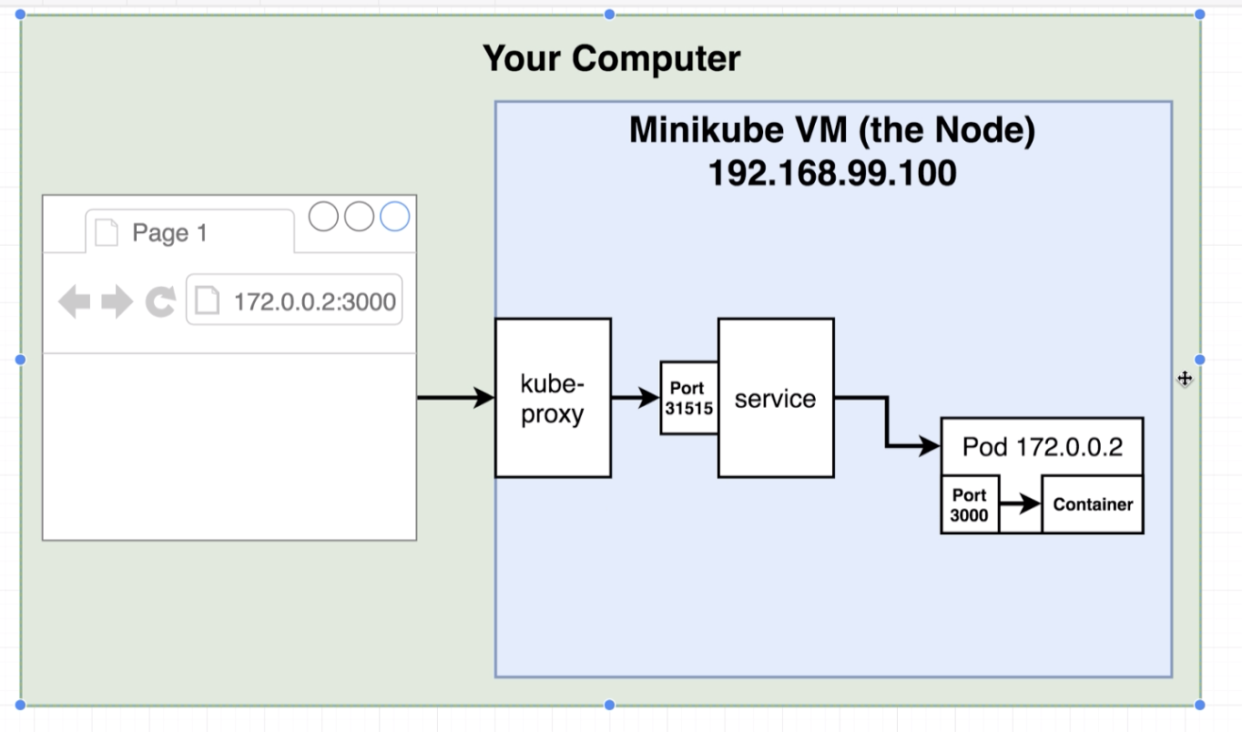

* **Scaling and Changing Deployments:**

apiVersion: apps/v1

kind: Deployment

metadata:

name: client-deployment

spec:

replicas: 1

selector:

matchLabels:

component: web

template:

metadata:

labels:

component: web

spec:

containers:

- name: client

image: stephengrider/multi-client

ports:

- containerPort: 9999

Change the replicas:

apiVersion: apps/v1

kind: Deployment

metadata:

name: client-deployment

spec:

replicas: 5

selector:

matchLabels:

component: web

template:

metadata:

labels:

component: web

spec:

containers:

- name: client

image: stephengrider/multi-client

ports:

- containerPort: 9999

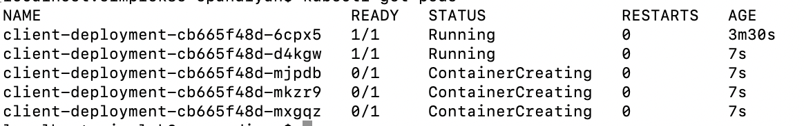

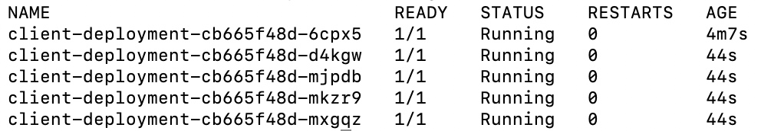

Change the image: multi-worker

apiVersion: apps/v1

kind: Deployment

metadata:

name: client-deployment

spec:

replicas: 5

selector:

matchLabels:

component: web

template:

metadata:

labels:

component: web

spec:

containers:

- name: client

image: stephengrider/multi-worker

ports:

- containerPort: 9999

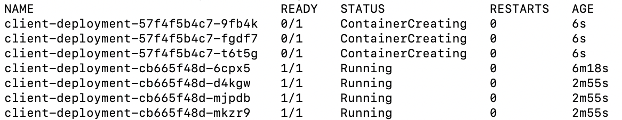

* **Updating Deployment Images:**

How to get the latest version of image, in case of any changes made to the image already running.

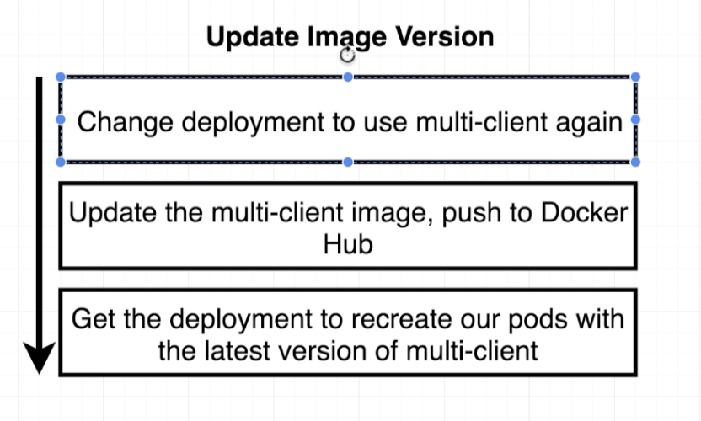

apiVersion: apps/v1

kind: Deployment

metadata:

name: client-deployment

spec:

replicas: 1

selector:

matchLabels:

component: web

template:

metadata:

labels:

component: web

spec:

containers:

- name: client

image: stephengrider/multi-client

ports:

- containerPort: 3000

**Apply the changes.**

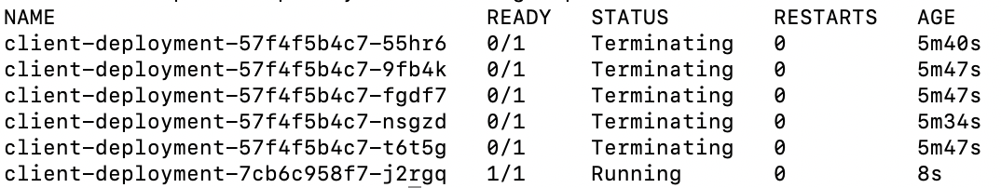



* **Rebuilding Client Image:**

Go to the client project and change the content of H1 to “Fib Calculator version 2”

Build and push the image to docker hub.

* **Triggering Deployment Updates:**

**Note:** Updating the latest image with deployment is not an easy thing, as you know, if you want to do the update, we must do some changes to the deployment file.

If there is no change in the deployment configuration, it will not do anything just by printing below message. Even though you updated the image in docker.

deployment.apps/client-deployment unchanged

**Possible Solutions:**

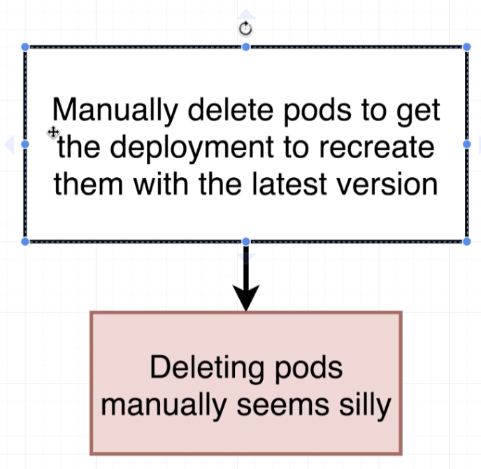

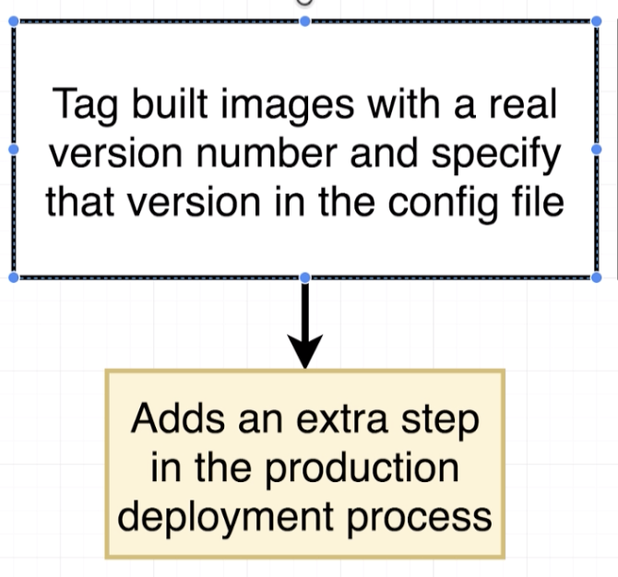

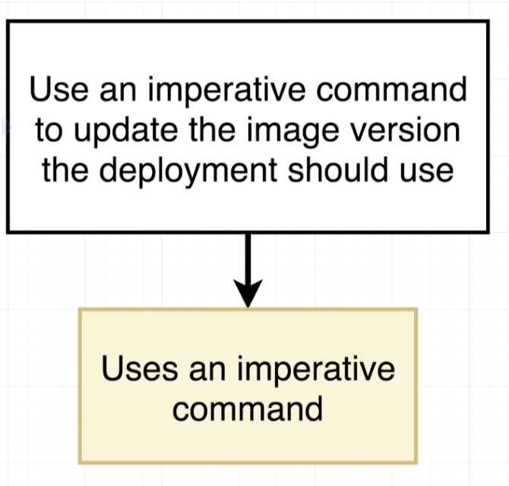

* **Imperatively Updating a Deployment’s Image:**

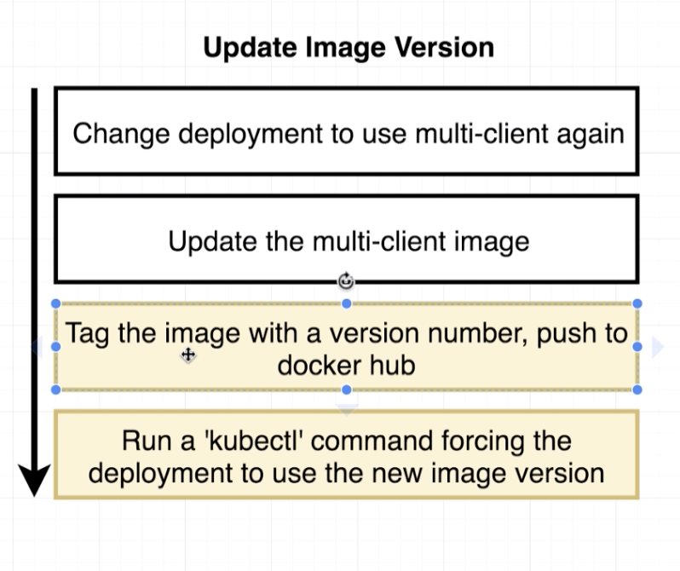

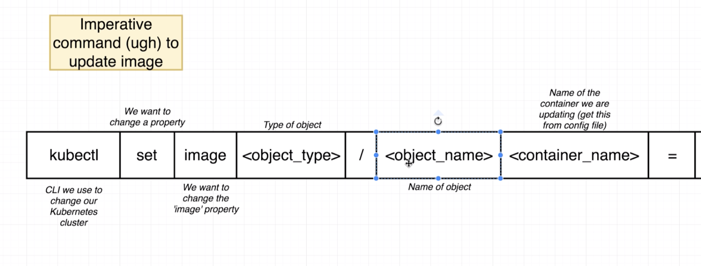

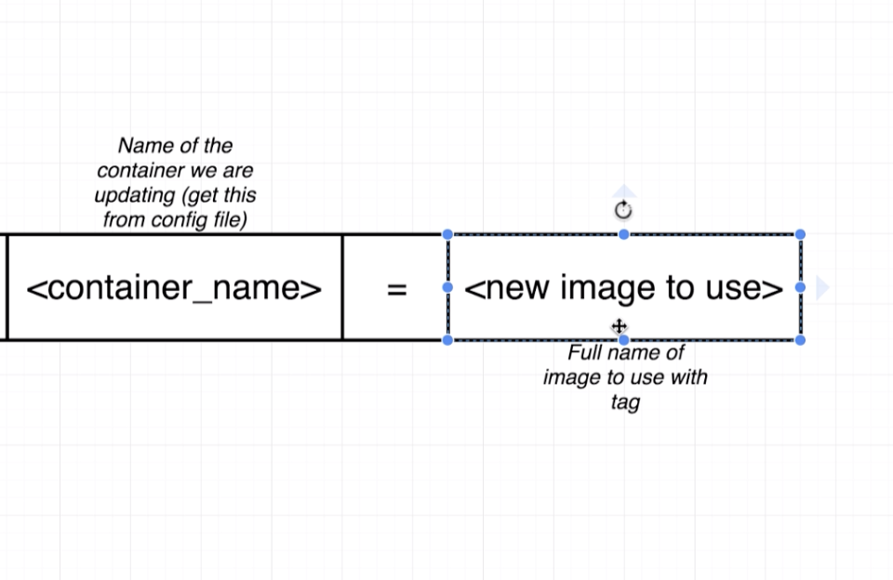

kubectl set image dpeloyment/client-deployment client=stephengrider/multi-client:v5

Once the image is updated successfully, it will print the message like below.

deployment.apps/client-deployment image updated

* **Multiple Docker Installations:**

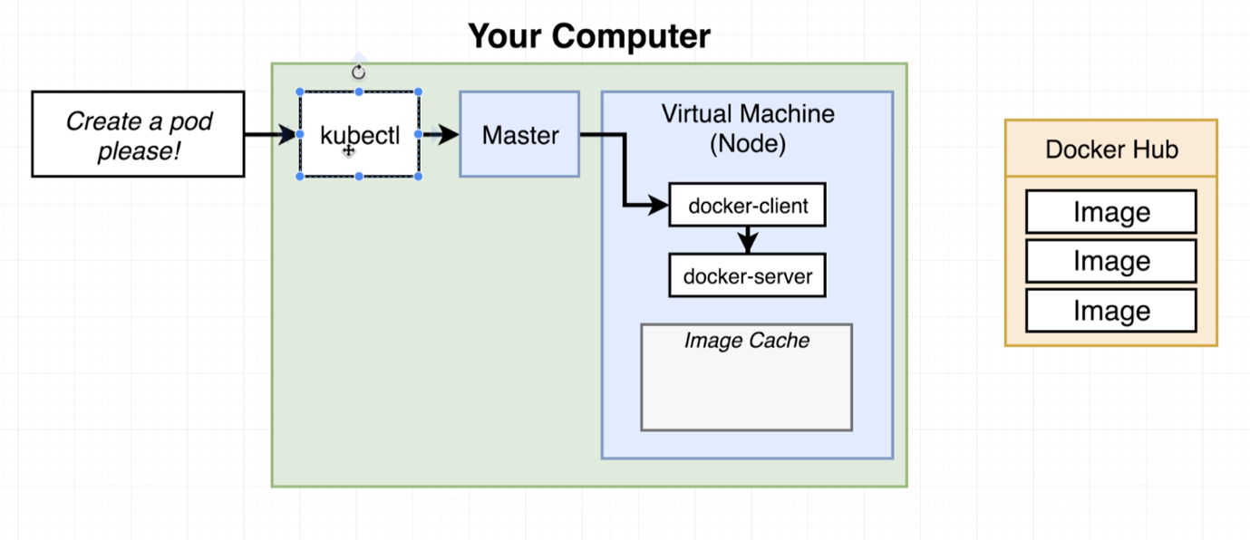

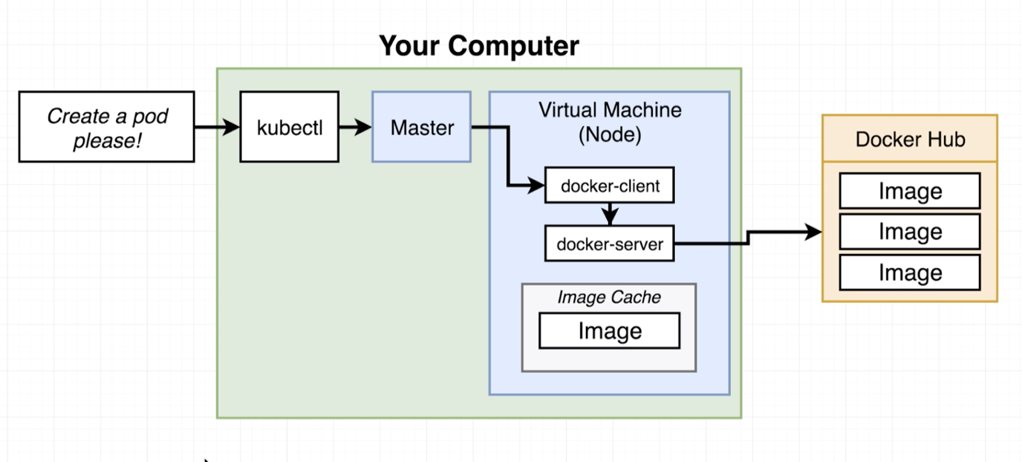

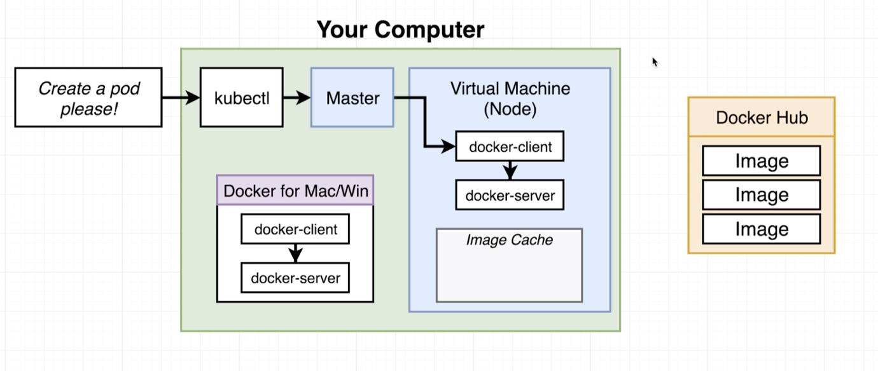

**Note:**

Whenever we use separate node (minikube) for cluster, the minikube installs a separate docker instance inside the VM, apart from the docker comes with “docker desktop”.

So if you run the “docker ps” within the “docker desktop” version, it will show the containers in the “docker desktop”.

If you run the same command inside the “minikube VM”, it shows a different result.

* **Reconfiguring Docker CLI:**

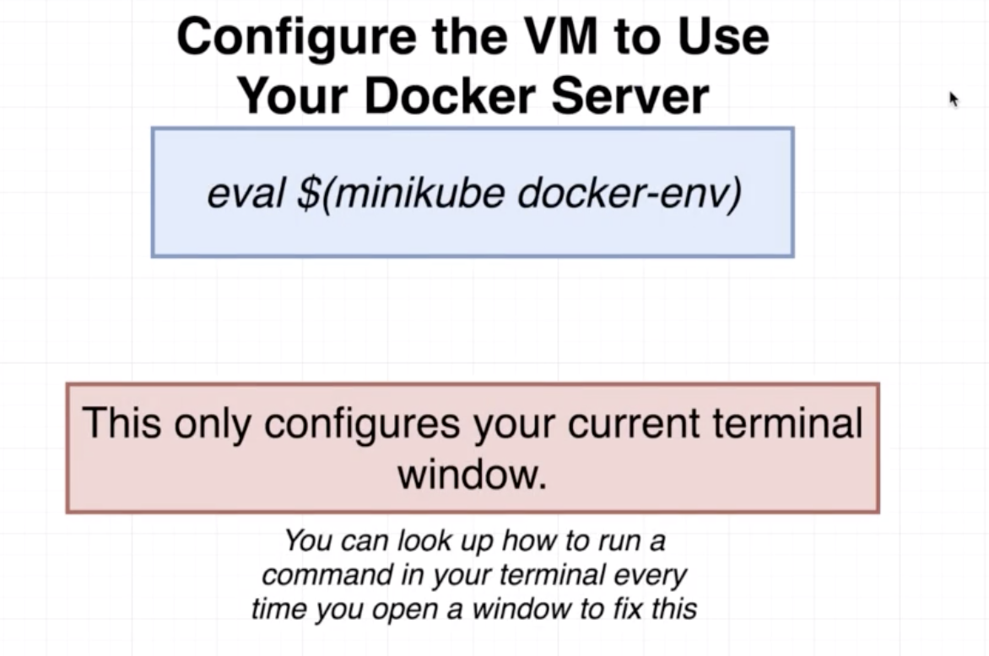

* **Why Mess with Docker in the Node?**

